**Out fitters jeans for girls**

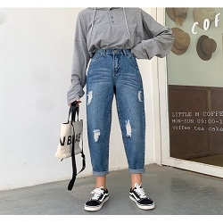

**SIMPLE JEANS**

**PKR 6000**

Jean size : 17

jeans waist: 33

**MORE INFORMATION:**

|  |  |
| --- | --- |
|  | |
| **Color** | Blue & White |
| **Product Category** | Ladies jeans |
| **Volume** | Volume 2 2022 |
| **Collection** | Midwinter '22 |
| **Fabric** | Jeans |
| **Disclaimer** | Due to the photographic lighting & different screen calibrations, the colors of the original product may slightly vary from the picture |

**More colors**  Neavy blue , Skin color , Black